Implement Perceptron-based Iris Classification
Aim
To implement the Perceptron algorithm in Python for classifying the Iris flower dataset and evaluate its performance using Accuracy, Confusion Matrix, and Classification Report.

Apparatus Required
- Google Colab / Jupyter Notebook
- Python 3
- Libraries:
  - NumPy
  - Pandas
  - Scikit-learn (sklearn)
Theory
The Perceptron is one of the simplest supervised machine learning algorithms used for classification. It is a single-layer neural network that learns a linear decision boundary by adjusting its weights based on classification errors.
The Iris dataset contains 150 flower samples belonging to three species:
- Iris Setosa
- Iris Versicolor
- Iris Virginica
Each sample has four features:
- Sepal Length
- Sepal Width
- Petal Length
- Petal Width
The Perceptron learns from the training data and predicts the class of unseen flower samples.

Algorithm
- Import the required libraries.
- Load the Iris dataset.
- Split the dataset into training and testing sets.
- Standardize the feature values.
- Train the Perceptron classifier.
- Predict the class labels for the test data.
- Calculate Accuracy.
- Display the Confusion Matrix and Classification Report.

Code (Google Colab)
from sklearn.datasets import load_iris
from sklearn.model_selection import train_test_split
from sklearn.preprocessing import StandardScaler
from sklearn.linear_model import Perceptron
from sklearn.metrics import accuracy_score, confusion_matrix, classification_report

# Load Iris dataset
iris = load_iris()
X = iris.data
y = iris.target

# Split dataset
X_train, X_test, y_train, y_test = train_test_split(
X, y, test_size=0.3, random_state=42
)

# Feature Scaling
scaler = StandardScaler()
X_train = scaler.fit_transform(X_train)
X_test = scaler.transform(X_test)

# Create and train Perceptron model
model = Perceptron(max_iter=1000, random_state=42)
model.fit(X_train, y_train)

# Predict
y_pred = model.predict(X_test)

# Display results
print("Predicted Classes:")
print(y_pred)

print("\nAccuracy:")
print(accuracy_score(y_test, y_pred))

print("\nConfusion Matrix:")
print(confusion_matrix(y_test, y_pred))

print("\nClassification Report:")
print(classification_report(y_test, y_pred, target_names=iris.target_names))

Sample Output
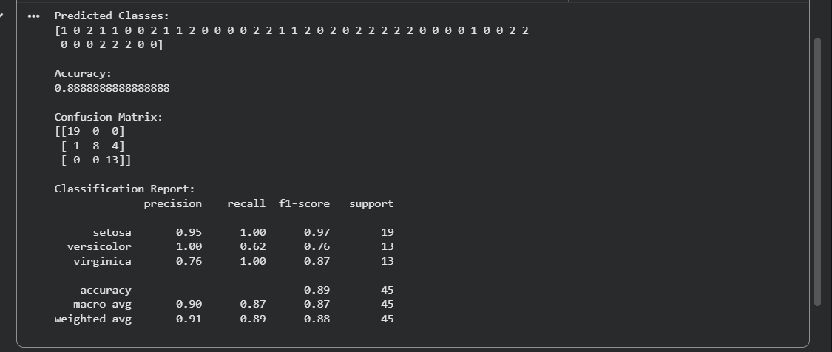
Result
The Perceptron-based Iris Classification was successfully implemented in Python. The model classified the Iris flowers into Setosa, Versicolor, and Virginica, and its performance was evaluated using Accuracy, Confusion Matrix, and the Classification Report.

